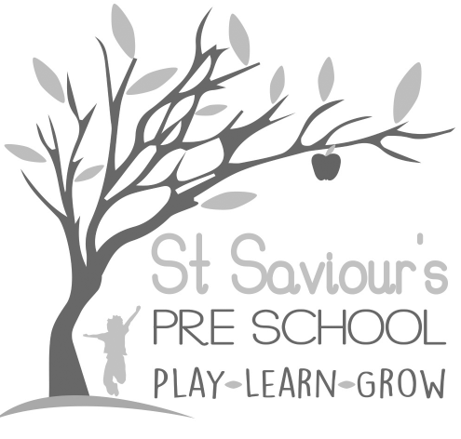
10.1 ADMISSIONS

Written by: Claire Toms and Tina Alder Date: 1.9.22 – reviewed 08.10.24.

Policy Statement
We aim to make St Saviour’s Pre-school and Nursery accessible to families from all sections of the local community. We will advertise the pre-school in places where all sections of the community have access, ensuring our service is inclusive, welcoming and reflective of the diversity of the community we serve.

Procedures

Pre-school Places
- Our waiting list will be arranged in order of receipt of a completed Registration Form.
- In line with EYFS 2025, priority will also be given to children who are Looked After by the Local Authority (LAC), previously LAC, or who have an Education, Health and Care Plan (EHCP).

Nursery Places – Maximum 16 Children
Places will be allocated according to the following criteria if oversubscribed:
- Children with an EHCP or who are Looked After (LAC) or previously LAC.
- Child currently attends St Saviour’s Pre-school.
- A sibling has attended St Saviour’s Pre-school.
- Date of receipt of Nursery Registration Form.
- All existing pre-school children will receive their Nursery application forms on the same day.
- We will, wherever possible, keep a place vacant to accommodate emergency admissions.

Inclusion and Equal Opportunities
- We will endeavour to make our pre-school welcoming to parents, relations, carers and people from all ethnic, religious and social groups, with and without disabilities.
- We make reasonable adjustments to ensure all children, including those with SEND or disabilities, can access our provision.
- We monitor the gender, ethnic background and additional needs of children joining the group to ensure that no accidental discrimination takes place.

Admissions Timing
- Children are admitted to the Pre-school each year in September.
- If places are available, admissions will also be offered in January and April, according to the date of registration.
- Mid-term admissions may also be considered if places are available.

Funded Places
- We offer funded places in accordance with the Early Years Entitlement and HCC’s Code of Practice.
- This includes:
  - Universal 15 hours for all 3- and 4-year-olds
  - Extended 30 hours where eligible
  - 15 hours for eligible 2-year-olds
- We also follow the 2025 EYFS requirement to avoid charging top-up fees that restrict access to funded hours.

